CSS 360 – Spring 2015

Professor Valentin Razmov

April 27, 2015

By:

Kalee Flenniken

Chris DuBois

Niki Tran

Bonnie Yip

Rob Stachofsky

Mark Fieser

Interactive Study Tool: Requirements, Specification, Architecture

# OVERVIEW

“Tell me and I forget. Teach me and I remember. Involve me and I learn.” –Benjamin Franklin

Interactive Study will be an easily accessible study tool that can be used at leisure. The purpose of this study tool is to empower learning by providing an alternate environment from traditional study habits. This environment will allow the users to be involved in the process by completing a series of questions in various topics.

The target audience for a study application would include students as well as the general population interested in learning a new concept. Because students circulate, there will always be a customer base for a study application. Some key topics that will be covered in this app are Software Development and various CSS topics. This application will be made to incorporate multiple subjects and topics pending the time schedule.

The purpose of this application is to empower learning in an interactive and fun environment. The main goals of this application include but are not limited to:

* Providing intellectually stimulating multiple choice questions.
* Providing answers as well as explanations to help the user internalize the information.
* Allowing a topic choice for the user so they are able to decide what topic they would like to practice.

Some of the goals pending a time schedule include:

* Detailed information regarding the scores of the user and others.

# Requirements

***Figure 1. A sample user experience***

***(1-1: Main Page)***

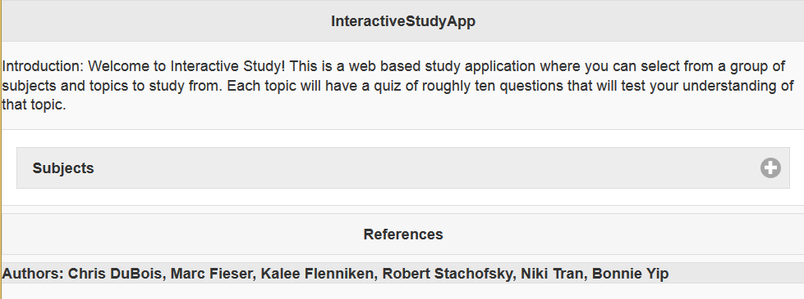

**(1-2: Drop down subject list)**

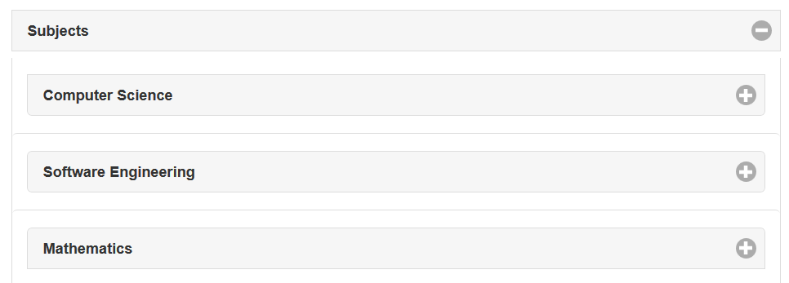

**(1-3: Drop down topic list)**

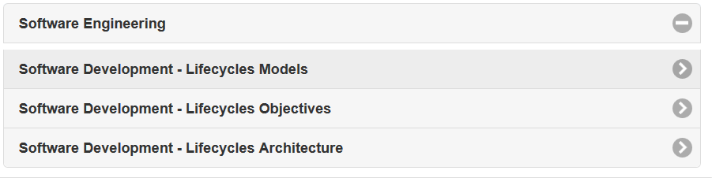

**(1-4: Quiz start page)**



**(1-5: Quiz Page)**

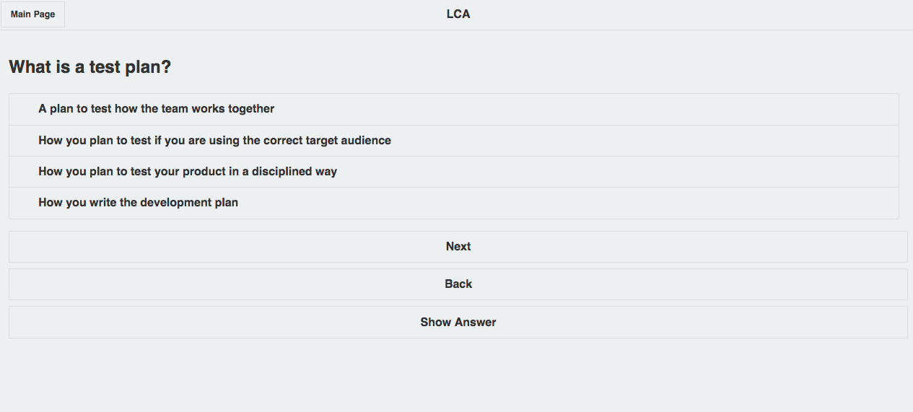

*Figure 1* demonstrates a mock-up of the Interactive Study App from a user’s perspective, where the general target audience are students looking to quickly study up before critical tests. The project’s scope as it stands, extends only to subjects of entry level Computer Science. Interactive Study will contain a list of pertinent subjects found in early computer programming courses and provide questions for each section within this list in the format of multiple choice, and true/false questions. At each stage in a quiz, the user will have the option to return to the previous question, or view the solution. Additionally, the user can return to the main page at any point in time.

When executed, *Interactive Study* will display a main page (*Figure 1-1*), containing a list of subjects and a link to the resources page. *Interactive Study* will also have a dropdown menu (*Figure 1-2 & 1-3*) of subjects that will in turn drop down to a list of topics. When a topic is selected, the user will be prompted to begin a quiz on that topic (*Figure 1-4*). The quiz will contain a list of questions and answers for the user to choose from (*Figure 1-5 & 1-6*). *Figure 1* displays a basic user interface of this design.

**Risks and Mitigation**

|  |  |
| --- | --- |
| **High-Risk Aspect** | **Risk Mitigation Plan** |
| Linking multiple application pages and locally stored application data | Import JQuery Mobile libraries and existing 3rd party storage. |
| Lack of knowledge of JavaScript,  HTML5, and CSS3 | Pair-programming, teamwork, and heavy use of existing tutorials and online resources.  Backup plan is to use WordPress Mobile |
| Lack of relevant questions | Provides proof of concept. As computer science students, we will commit to writing x number of questions to be added to the application. |
| With a highly limited scope, is the application still a minimal viable product? | The project will be designed and developed to be expandable. |

**Class Diagram**

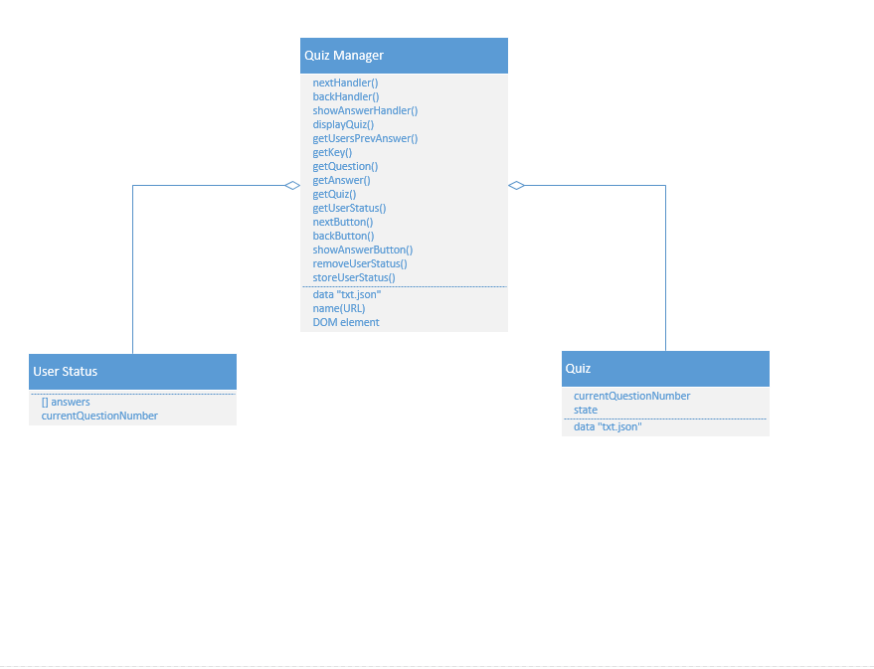

The figure above illustrates the objects utilized to create an interactive quiz displayed by altering a DOM element.

Quiz Manager – Manages interactivity and allows other objects to communicate with each other.

User Status – Used to track user’s progress through the quiz.

Quiz – Object that holds data related to quizzes.

**Sequence Diagram**

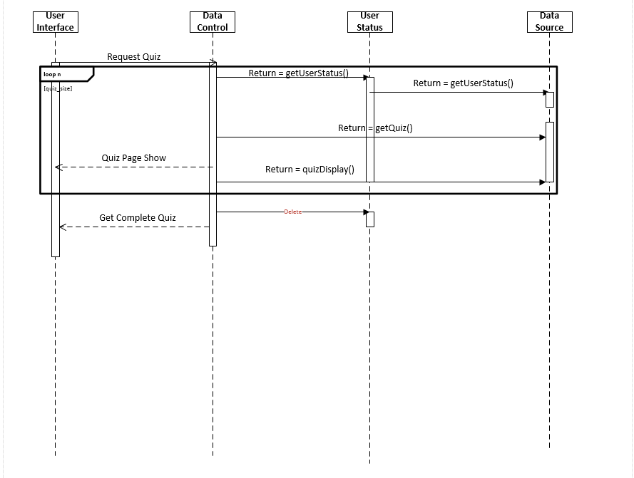

The figure above illustrates the most successful use case.

**Software Components**

**Apache Cordova**

* A set of device APIs that allows access to native device function from Javascript, combined with JQuery Mobile, this allows a Smartphone app with just HTML5/CSS3 and Javascript, rather than native OS specific languages (such as Swift, Objective C, Java, etc.)

**PhoneGap – Build**

* PhoneGap builds on top of Apache Cordova, and is a tool that can be used by JQuery Mobile Javascript, HTML5/CSS3 development to wrap code for native app development.

**JQuery Mobile – Javascript, HTML5/CSS3**

* JQuery mobile is a set of libraries optimized for Touch based, HTML based user interface, designed to make apps accessible on all smartphone and desktop devices. JQuery Mobile pulls from JQuery and JQuery UI and uses AJAX for page navigation and linking with the browser.

**Use and Details**

JQuery Mobile’s data-role = “key” function develop pages, and code using HTML5/CSS3 for both buttons, style, and pages.

JQuery Mobile’s data-dom-cache=”true” functions to ensure the application’s browser will not overload with data (as multiple pages will have to be loaded

JQuery Mobile’s viewport metatags allow for dynamic screen resizing for any device

JQuery Mobile’s data-rel=”back” for stack anchoring, stepping back through the hrefs stored, relocating the app to the previous link via a Javascript reverse button

Along with the above standard HTML5/CSS3 and JavaScript is used to call functions to database information, navigate pages, and generally design the application.

# Use Cases

Table 1. Use case 1

|  |  |
| --- | --- |
| Goals | Test their knowledge on a particular topic |
| Primary Actors | Undergraduate students |
| Pre-Conditions | Access to the app on a mobile device |
| Successful post-condition | Receive a correct score for answers provided by the user |
| Unsuccessful post-condition | No score was given |
| Trigger | Choose a subject to be tested on |
| Main success scenario | The student enters the app   * Chooses a topic to study * Provides answers the quiz questions * Receives a score |
| Failure scenario | The student enters the app   * Chooses a topic to study * Provides answers the quiz questions * Does not receive a score or incorrectly calculated score |

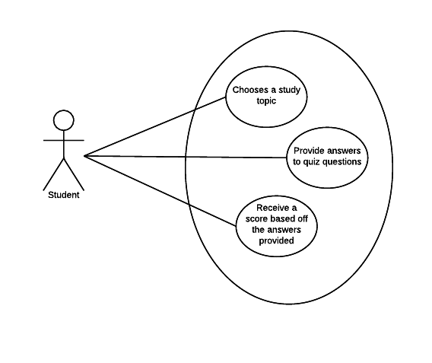

Figure 1: Basic Use Case

Table 2. Use Case 2

|  |  |
| --- | --- |
| Goals | Resume a quiz after soft exiting the application |
| Primary Actors | Undergraduate students |
| Pre-Conditions | Access to the app on a mobile device |
| Successful post-condition | Resume to the previous state, before soft exiting the app |
| Unsuccessful post-condition | History lost, resume at a new state |
| Trigger | Phone call or email notification |
| Main success scenario | The student enters the app   * Chooses a topic to study * Take a break from the quiz * Soft exits the app * Resume quiz at the same state when left and continue answering questions * Receives a score |
| Failure scenario | The student enters the app   * Chooses a topic to study * Exits the quiz with soft close * Loses all history of scores and resume at a new state |

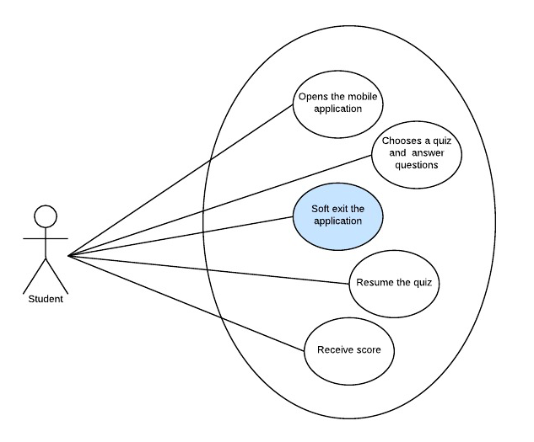

# Usability Testing

The usability testing questionnaire can be found in the document titled*: Interactive Study Tool_Usability Testing Questionaire.*

The results are highlighted in the following screen shots: The document containing the results is titled *Interactive Study Tool_Usability Testing Results*

